


面向对象程序设计
课程设计报告

题 目 高校人事管理系统

学生姓名 黄家睿

学 号 202283890036

院 系 沃特福德学院

专 业 物联网工程（合作）

年 级 2022级

教 师 廖灵芝

二Ｏ二三年 十二 月 二十九 日

目 录

1 Literature Review 4
2 System Design 4
2.1 Functional structure 4
2.2 Business processes 5
2.2.1 Add a student 5
2.2.2 delete a student 5
2.2.3 display student 5
2.2.4 search a student 5
2.2.5 modify a student 6
2.2.6 exit 6
3 Detailed Design 6
3.1 Data structure design 6
3.2 Main menu design 6
3.3 Class hierarchical design 7
3.4 Class design 7
3.4.1 Student class 7
3.4.2 studentManger class 7
3.4.3 MainMenu class 9
4 System Implementation 9
4.1 showMenu 9
4.2 studentManager 11
（1） addStudent 11
（2） removeStudent 12
（3） displayStudent 12
（4） searchStudent 12
（5） modifyStudent 13
（6） load function 13
（7） save function 14
5 System testing 14
5.1 Data preparation 14
5.2 Test results 15
5.2.1 display student 15
5.2.2 search student 15
5.2.3 modify student 15
5.2.4 add student 16
5.2.5 delete student 16
6 Conclusion 17
6.1 Conclusion 17
6.2 Analysis 17

高校人事管理系统
黄家睿
NUIST Waterford Institute, Nanjing 210044, China

Abstract: 在本次课题中，我们通过c++语言编写了一个高校人事管理系统，通过使用vector作为学生信息的数据结构，并引入fstream的头文件将所有的数据记录在计算机的一个文本文档中，解决了学校对于校内学生的管理的问题。
Key words: 管理系统，数据结构，学生管理，c++

Personnel Management System of Colleges and Universities
Jiarui Huang
NUIST Waterford Institute, Nanjing 210044, China

Abstract: In this project, we wrote a university personnel management system through C++ language, using Vector as the data structure of student information, and introducing the header file of Fstream to record all the data in a text file on the computer, which solves the problem of school management of students in the school.
Key words: Management system，data structure，Student management，c++
- Literature Review
Personnel management systems play an important role in modern society. As one of the important areas of personnel management, personnel management in colleges and universities also needs an efficient personnel management system to assist in management. The development process of the personnel management system can be traced back to the sixties of the last century, with the development of computer technology, the personnel management system has been rapidly developed. The application of personnel management system can improve the efficiency of personnel management, reduce the cost of human resource management, and improve the quality of human resource management. The application of the personnel management system in colleges and universities can help colleges and universities to better manage human resources and improve the management level and management efficiency of colleges and universities. Therefore, the research and development of personnel management system in colleges and universities has important practical significance and theoretical value.
- System Design
  - Functional structure
In this project, I created three classes to manage the HR system, namely the Students class, the Student Management class, and the Main Menu class. The student management class sets up a vector of the student class to achieve operations such as adding, deleting, modifying, and overviewing. The student management class interacts with the user through the main menu class.
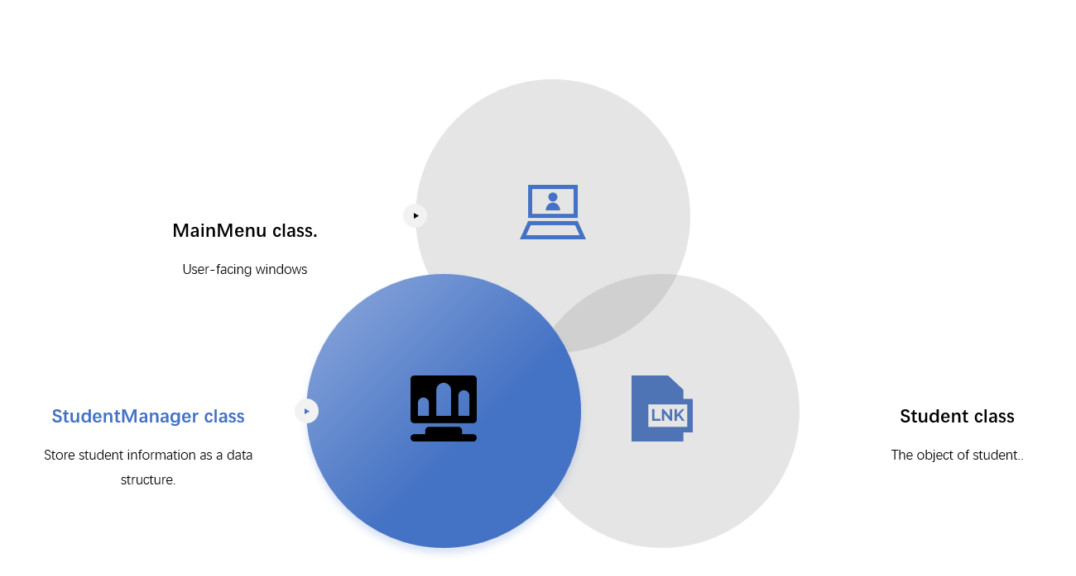

  - Business processes
    - Add a student
In the main menu, users can enter "1" to initiate the addition of student services. The user is then prompted to enter the student's name, and after pressing the enter key, the user is prompted to enter the student's grade. After pressing the enter key, the system will successfully enter the information of a new student (including name and grade).
    - delete a student
In the main menu, users can enter "2" to start the service of deleting student information. The user is then prompted to enter the name of the student they want to delete, and after pressing enter, the student's information will be deleted.
    - display student
In the main menu, users can enter "3" to give an overview of the student information service. The system then prints out all the student information recorded in the vector on the console.
    - search a student
In the main menu, users can search for student information by typing "4", and then you will be prompted to enter the name of the student you want to query, press enter after entering, and the information of the renamed student will be printed on the console.

    - modify a student
In the main menu, users can enter "5" to start the service to modify student information. Then you will be prompted to enter the name of the student you want to modify, press the enter key, and when prompted to enter a new grade, the system will re-enter the student's new score after pressing the enter key.
    - exit
When the user enters "0", the app will be closed, but the actions performed before the end will be retained.
- Detailed Design
  - Data structure design
Vector is a type of sequence container in the C++ Standard Template Library (STL). It can hold any type of element like integers, floats, strings, etc., and can dynamically increase and decrease elements.
Here are some of the main features of vectors:
- Dynamic arrays：A vector stores elements in memory in a continuous marrer, just like an array, the size of a vector can be dynamically changed at runtime.
- Random visits：We can use the index to directly access any element in the vector, which is very fast.
- Insert and delete：We can add or remove element at the end of the vector. However, inserting or deleting an element in the middle or beginning position may cause other elements to move, which may take more time.
  - Main menu design
In order to achieve user-friendly interaction, the main menu contains 6 options, which correspond to the following functions：
- Add student
- Delete student
- Display student
- Search student
- Modify student
- Exit
Users only need to enter the corresponding business number, press the space bar to confirm, and then they can handle the relevant affairs

  - Class hierarchical design
In this project, three classes were created to implement the various methods in the main menu. By customizing a student class, two elements of name and grade are added to the student class, and the studentManger class is used to manage the student class, including adding, deleting, overviewing, searching and modifying. All the functions in the studentManger class are implemented through the user-friendly interface and user interaction of the MainMenu class.
  - Class design
    - Student class
Two member variables are defined in this class, the name of the string type and the score of the int type, which are used to store the student's name and grade, respectively, and encapsulate the name and score to ensure that they cannot be modified due to special cases.
When you create a new student object in the MainMenu, you need to enter the student's name and grade.
Both the name and score methods in the Student class have corresponding get methods, but only score has a setScore method, which prevents accidental name changes and subsequent modifications to score in the modify method.
The const keyword is added to the end of both the getName and getScore methods, indicating that the function does not modify the member variables of the class. Doing so makes the program more stable and avoids accidental modifications. If you try to modify a member variable in a member function, the compiler will report an error.
    - studentManger class
There are two member variables in the studentManager, which are a vector named students and a filename of type Student.
Vector is used to store the data structure of the student class, and the data is managed through various default methods of vector. Filename is to save and load the data in the vector on the disk of the computer by introducing the fstream header file.
Membership Methods：
- add student function
When using this method, you need to enter two variables into the method, name and score, and then create a new student class with the two variables entered, and then use the vector's push_back method to press the new student class into the vector. Finally, use the saveToFile method to save the newly added data on the disk of your computer.
- delete student function
When using this method, you need to enter the name of the student you want to delete into the method, and then the program will iterate through the vector, find the student class containing the name through the getName method in the student class, and delete this class. Finally, use saveToFile to save the data.
- display student function
This method iterates through all the classes in the vector and prints the data contained in each class in the console.
- search student function
To do this, you need to enter the name parameter of the student you want to search for, and then use the for loop to iterate through each element in the students set to find the student class that contains the name. If a matching student is found, the student's name and score are output. Otherwise, the output is "No information found".
- modify student function
This method needs to first enter the name of the student parameter that the user wants to modify and the new grade of the student, after receiving the name parameter, this method will use a for loop to traverse each student class in the vector, find the student class, use the setScore method to set the new score of the renamed student, and finally use the saveToFile method to save the data on the computer disk. If you can't find the student class with this name parameter, the console will print "No information found, unable to modify" to automatically exit the method.
- save function
This method writes the data from the students vector to a file. The function first opens a file named filename using the ofstream class. If the file opens successfully, the function uses the << operator to write the data from the students vector to the file line by line. The first word of each line is name, and the second word is score. Finally, the function closes the file using the close() method . The method starts to save data every time student information is added, deleted, changed.
- load function
This method is set on the first line of the main method, which automatically reads previously saved data from the computer disk every time the program starts, and when the program starts, it reads the data from the file and stores it in a vector of Student objects. The function first opens a file named filename using the ifstream class. If the file opens successfully, the function uses the >> operator to read the data in the file line by line. The first word of each row is stored in the name variable, and the second word is stored in the score variable. Then create a new Student object with the name and score values and add it to the students vector using the push_back() method. Finally, the function closes the file using the close() method.
    - MainMenu class
This class provides a user-friendly interface that can be used to manage the student system in comparison with the methods in the studentManager class.
In this class, a member variable of the studentManager type is created, which is used to start the student Manager class to focus on various methods.
- The constructor of MainMenu
The constructor of MainMenu needs to accept a variable file of type string to initialize the member variable manager of the studentManager.

- showMenu
The showMenu method uses a switch method and a while loop implementation,

- System Implementation
  - showMenu
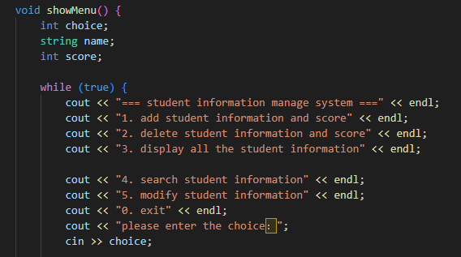
Figure 2：showMenu function

This shows the user interface, which prints the above code in the console after the program is launched. Finally, the program asks the user to enter a number to select the action they want to do.
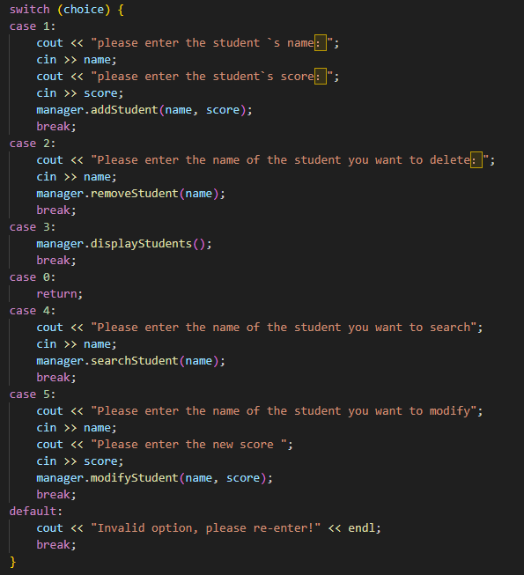
Figure 3：switch function in showMenu

This piece of code shows the implementation of the operation method corresponding to the options in the user interface. For example, if the user selects 1, the operation of adding students is started, and the switch will automatically start the operation corresponding to option 1, and the addStudent method in the manager is called to implement the operation of adding students.
  - studentManager
- addStudent
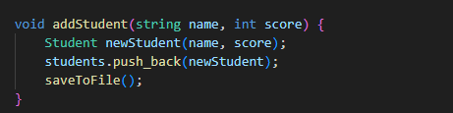
Figure 4：addStudent function

In this part of the code, add a new student to the student vector. This function has two parameters: name and score. It creates a new Student object with the given name and score and appends it to the end of the students vector using the push_back() method. Finally, it calls the saveToFile() function to save the updated vector to a file.
- removeStudent
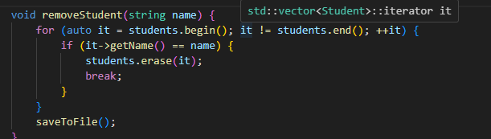
Figure 5：removeStudent function

The method uses a for loop to iterate over each student in the students vector, and if a name with the same name is found, the student is removed from the vector using the erase() method. Finally, it calls the saveToFile() function to save the updated vector to a file.
- displayStudent
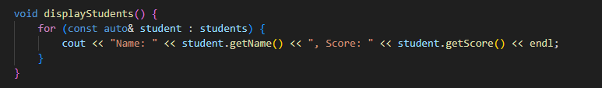
Figure 6：displayStudent function

Use the for loop to iterate over each student in the students vector, and use the getName() and getScore() methods to get the student's name and score. Finally, it uses the cout statement to output the student's name and score to the console.
- searchStudent
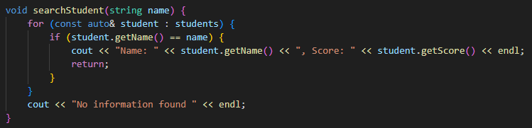
Figure 7：searchStudent function

Use a for loop to iterate through each student in the students vector, and if a name with the same name as name is found, the student's name and score are output. If no matching student is found, "No information found" is output.
- modifyStudent
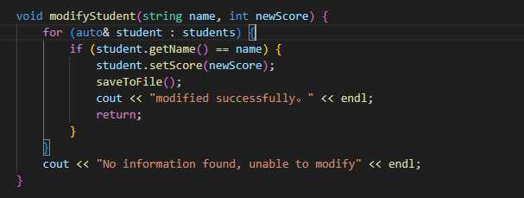
Figure 8：modifyStudent function

The function traverses the list of students and searches for students with matching names. If a match is found, the student's score is updated to the new score provided, and the updated information is saved to a file. The function then prints the "Modification Successful" to the console. If no match is found, the function prints "No information found, cannot be modified" to the console.
- load function
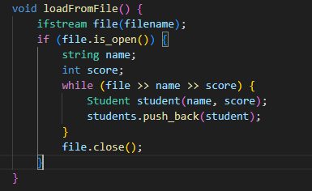
Figure 9：load function

The function opens a file named filename and reads the data in the file by row. Each row of data contains a student's name and score, separated by a space. The function then stores each student's name and score in a Student object and adds the object to a list called students. Finally, the function closes the file.
- save function
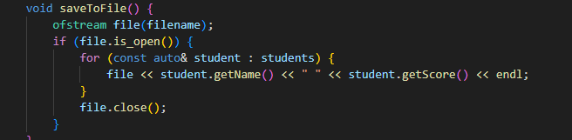 Figure 10：save function

The function opens a file named filename and writes each student's name and score into the file. Each student's name and score are separated by spaces, and each student's information takes up one line. Finally, the function closes the file.

- System testing
  - Data preparation
Before testing the program, prepare 4 pieces of data on disk.
Wangziheng | 100
Steven | 80
Hans | 80
Peter | 60

  - Test results
    - display student
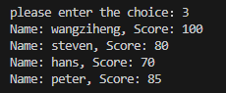
Figure 11：display show

When you enter "3" on the user selection screen, the data prepared on the disk is printed to the console.
    - search student
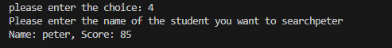
Figure 12：search show

I typed "4" into the user selection screen to start the search function, and then I tried to search for the previously added data "peter", and the search results were displayed in the console.
    - modify student
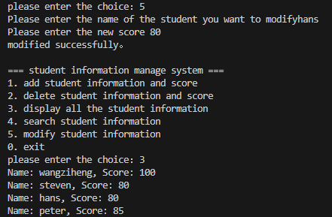
Figure 13：modify show

The first step is to enter "5" on the user selection screen to start the modification process, and then prompt the user to enter the name of the student to be modified first, in this step we enter the pre-existing data "hans", modify the score of hans to "80", and after confirmation, the program will tell us "modified successfully".
After that, we will go back to the user selection screen, we will type "3" to see all the user information, and we will see that the score of "hans" has been changed to "80".
    - add student
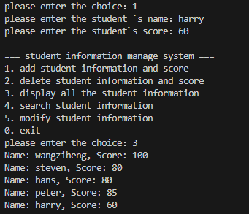
Figure 14：add show

The first step is to enter "1" in the user selection interface to start the process of adding students, and then prompt the user to enter the name of the student you want to add, in this step, we enter the name of the newly added student "Harry" and the grade of "harry" "60", after confirmation, the program will save the information of the newly added student on the computer disk.
After that, we'll go back to the user selection screen, and we type "3" to see all the user information, and we can see the "harry" information.

    - delete student
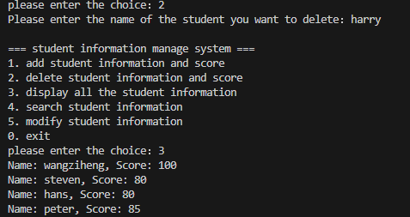
Figure 15：delete show

he first step is to enter "2" on the user selection screen to start the delete student program, then prompt the user to enter the name of the student you want to delete, press the enter key to confirm, the data will be removed from the vector, and finally call the save ToFile method to save the updated data to the file.
After that, we will go back to the user selection screen, we will type "3" to see all the user information, and we can see that the "harry" information has been deleted.

- Conclusion
  - Conclusion
In this project, we implemented a university information management system by using the C++ language.
In order to implement such a system, we use object-oriented programming ideas, encapsulating student information into a class, and implementing the operation of student information through the member functions of the class. Using vector as a data structure, you can easily add, delete, and modify student information. At the same time, using the fstream header file allows you to save student information to a file so that you can read it the next time you use it. And the fstream header file is used to implement the save and load functions, so that the data is saved on the computer's disk. Efficient management of student information has been realized.
  - Analysis
In this project, I only used the encapsulation idea of object-facing programming, and did not use the two important ideas of inheritance and polymorphism of object-facing programming. In terms of data structure, if you need to further optimize the performance of the system, you can consider using a data structure such as a hash table to store student information to improve the efficiency of finding and deleting elements.

